Independent-Samples t-Test (Social Skills)
A psychologist is examining the influence of an older sibling in the development of social skills. A sample of 19 three-year-old children is obtained. Half of these children had no siblings and the others had at least one older sibling who is within 5 years of the child’s age. The social skills score for each child is listed in the table. Do these data indicate that having an older sibling has a significant effect on the development of social skills?

Step 1. State your hypotheses.
a. Is it a one-tailed or two-tailed test?

b. Research hypotheses
H_{A}:

H₀:

c. Statistical hypotheses
H_{A}:

H₀:

Step 2. Set the significance level ➔ α = .05 Determine t_{crit}. t_{crit} =

Step 3. Compute the appropriate statistical test.
Older  Sibling  (X₁) |  | X – | (X –)²
5
6
7
8
10
7
8
7
6
8

No  Sibling  (X₂) |  | X – | (X –)²
3
6
4
5
4
3
2
7
5

Step 4. Make a decision. Determine whether the value of the test statistic is in the critical region. Draw a picture. Label t_{crit} and t_{obt}.
Is t_{obt} in the critical region?
Should you reject or retain the H₀?

Step 5. Report the statistical results.

Step 6. Write a conclusion.

Step 7. Compute the estimated d.

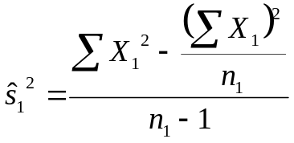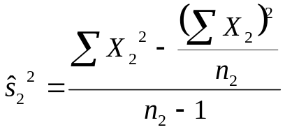

Step 8. Compute r² and write a conclusion.

